IALD Presents an Award of Excellence for the Bridge of Aspiration
Speirs and Major Associates Accepts Award
New York, NY, April 13, 2005 – The International Association of Lighting Designers (IALD) is pleased to present an Award of Excellence for the Bridge of Aspiration, a walkway connecting the Royal Ballet School and the Royal Opera House in Covent, London, United Kingdom. The entry was judged in the monumental structures/public spaces category. This year, seven projects earned awards of excellence, and three earned this recognition in the monumental structures/public spaces category. Principal lighting designer on the project is Jonathan Speirs, with Phillip Rose of Speirs and Major Associates, also in London, United Kingdom.
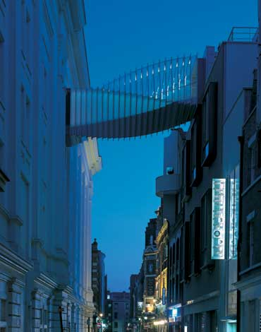 | 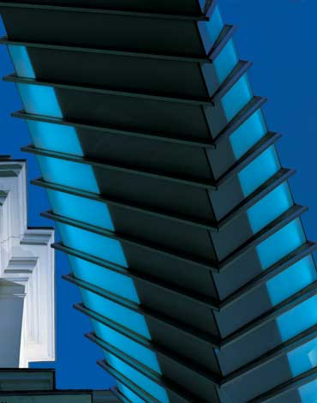 | 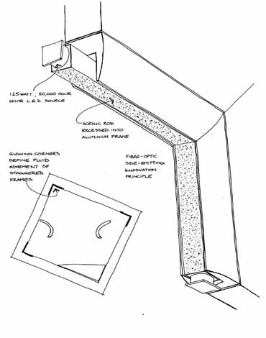 | 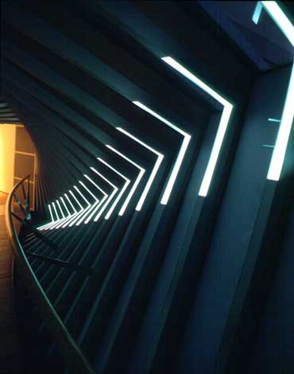 | 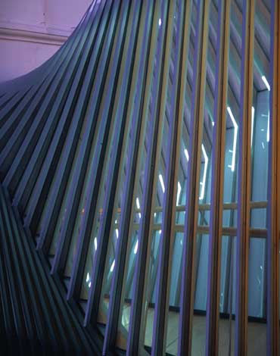
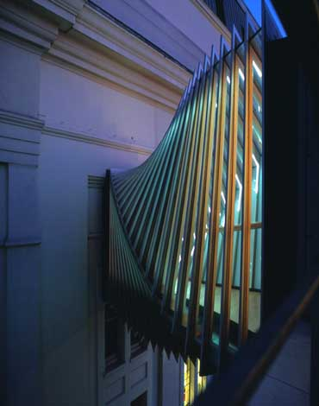 | 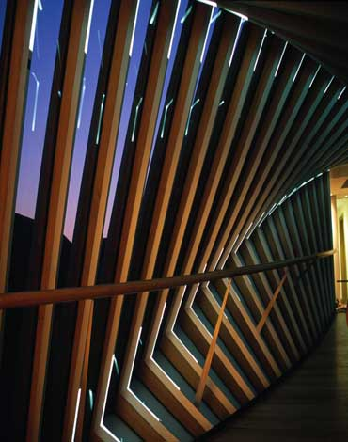 | 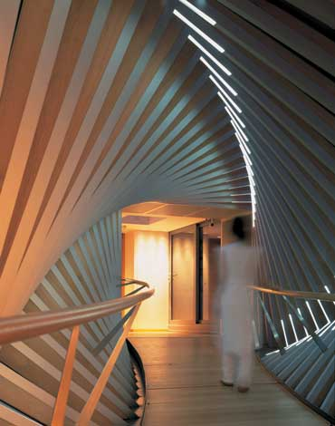 | 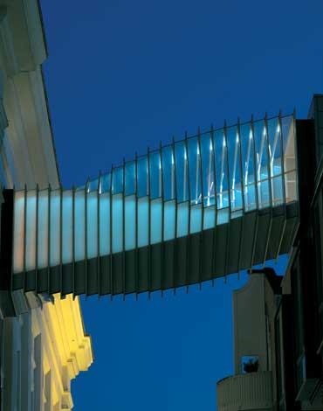
The primary challenge was to capture the dynamic form and innovative drama of the heliotropic design that changes level as it spans the street. Twenty-three square aluminum frames twist in four-degree steps that achieve a 90-degree shift from end to end. The lighting was to enhance the experience of those using the bridge, but be economical for equipment and running costs. The design solution graphically “draws” the frame with 57 L-shaped white LEDs integrated into the corners of the aluminum frames.
“This is a bridge that pirouettes across the space,” commented one judge. “It’s brilliant in terms of architecture and light.”
At this year’s 22nd annual event, the IALD awarded 23 projects that represented six of the seven categories. Seven IALD Awards of Excellence were awarded: one in both the corporate and retail/entertainment categories; two in site/façade; and three in the category of monumental structures/public spaces. The highest point earner wins the Radiance Award for Excellence in Architectural Lighting Design. In addition, fifteen projects also earned IALD Awards of Merit; two in both the hospitality and corporate categories; three in the site/façade category; and four in each the retail/entertainment and monumental structures/public spaces categories. An IALD Special Citation for innovative use of materials and techniques for daylighting control was granted for an entry in the academic/institutional category.
The IALD Lighting Design Awards program, established in 1983 and co-sponsored by Professional Lighting Design magazine, honors lighting projects that display high aesthetic achievement backed by technical expertise. Entries are submitted into one of seven categories: Academic/Institutional; Corporate; Hospitality; Monumental Structures/Public Spaces; Residential; Retail/Entertainment; and Site/Façade. Additionally, projects can also be submitted for consideration in the sustainable design award category, which means the project undergoes an additional round of judging keyed solely to the fulfillment of sustainable design principles. A panel of award-winning lighting designers and architects review the projects.
This year, the IALD received 141 submissions from 14 countries. The IALD, established in 1969, is an international organization dedicated to the profession of architectural lighting design. Based in Chicago and comprised of 700 members throughout North and South America, Europe, Asia and Australia, the IALD’s role is to set the global standard for lighting design excellence.
Additional information can be downloaded from www.IALD.org.

